ASSIGNMENT – 2
Name : R.Ashmitha Reddy
Batch : 40
Hall Ticket No : 2303A52111
Section 1: Section A — Vector Operations & Dot Product (CPU- bound, loop overhead)
Aim :
To measure the serial baseline performance of simple numerical operations-element-wise vector addition and dot product-implemented using pure Python loops, and to identify CPU-bound hotspots caused by loop overhead using profiling tools.
Requirements :
Software Requirements
- Python 3.8 or above
- Operating System: Windows / Linux / macOS
Libraries Used (Standard Library Only)
- time – measure execution time
- random – generate random vector values
- cProfile – profile CPU usage
- pstats – analyze profiling statistics
- io – capture profiler output
- tracemalloc – track memory consumption
Hardware Requirements
- Processor: Any standard CPU
- RAM: Minimum 2 GB (4 GB recommended)

Implementation Code :
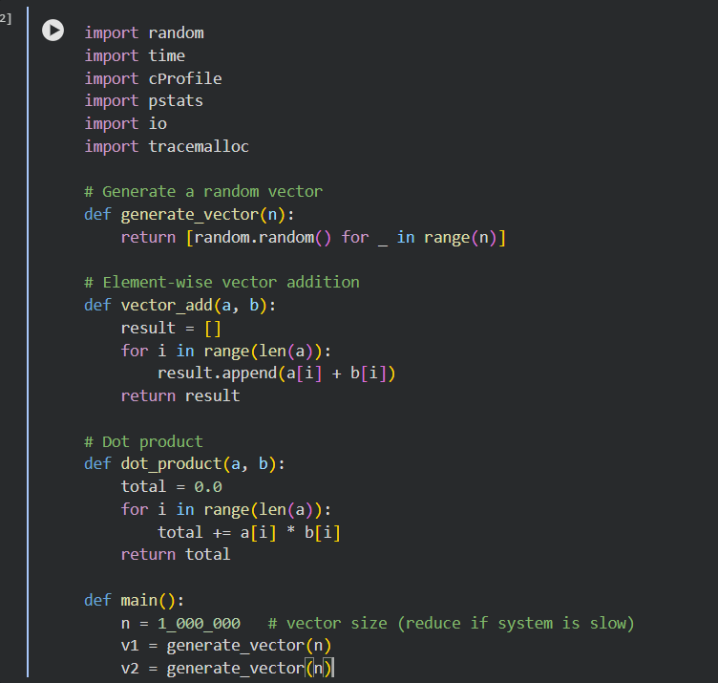
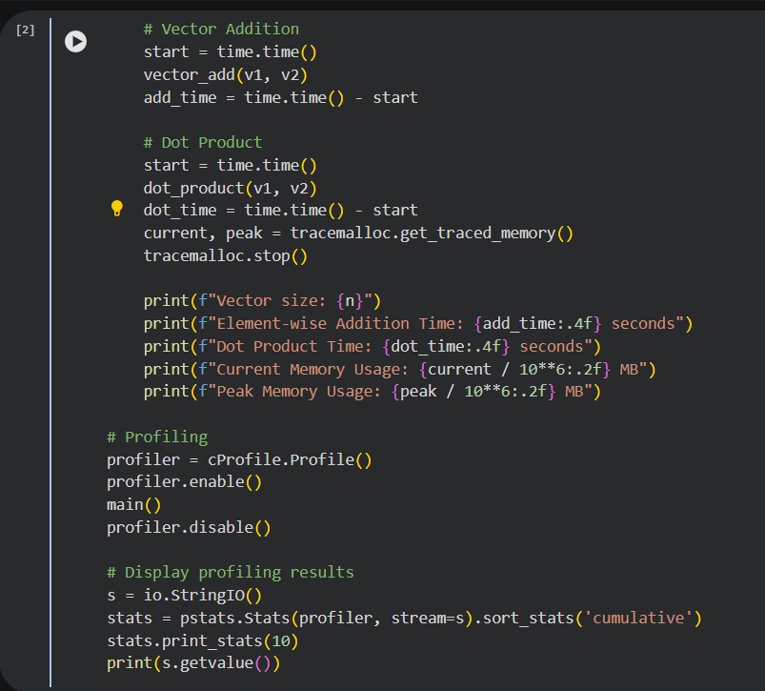
Output:
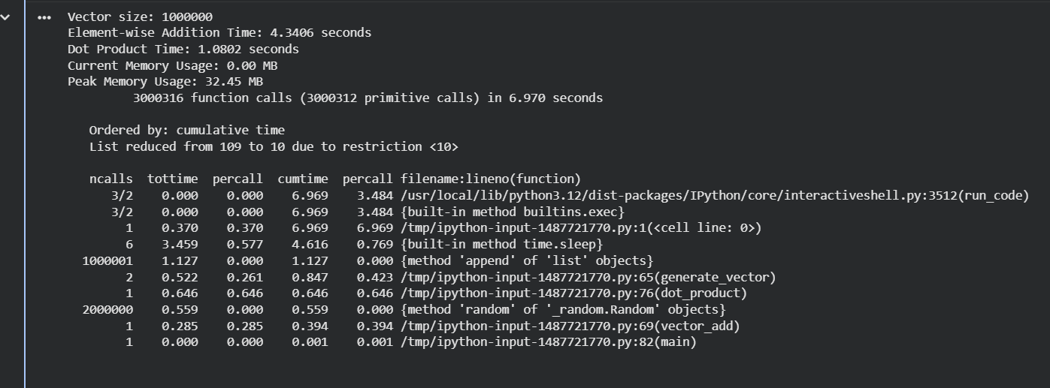
Section 2: Naïve Matrix Multiplication (O(n3) compute)
Aim :
To implement naïve matrix multiplication using a triple nested loop in Python, measure its serial execution performance, and analyze computational hotspots and memory usage using standard profiling tools.
Requirements :
Software Requirements
- Python 3.8 or higher
- Operating System: Windows / Linux / macOS
Libraries Used (Standard Library Only)
- time – to measure execution time
- random – to generate random matrix values
- cProfile – to profile function execution
- pstats – to analyze profiling results
- io – to capture profiling output
- tracemalloc – to track memory usage
Hardware Requirements
- Processor: Any modern CPU
- RAM: Minimum 4 GB (recommended for larger matrix sizes)

Implementation Code :
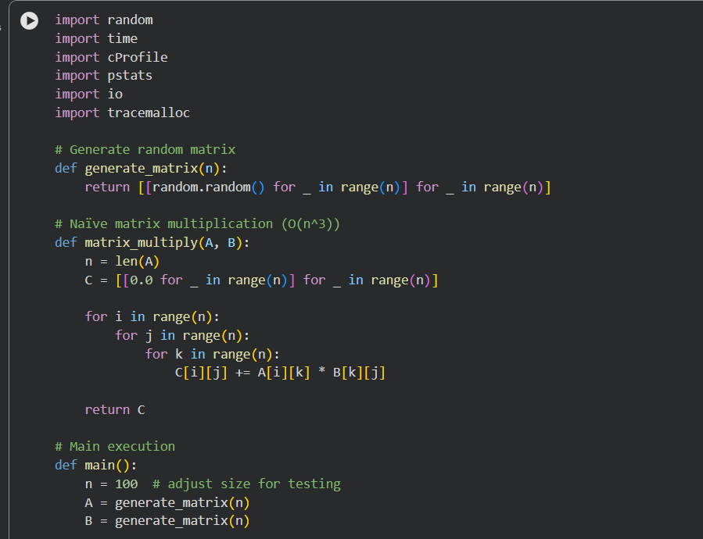
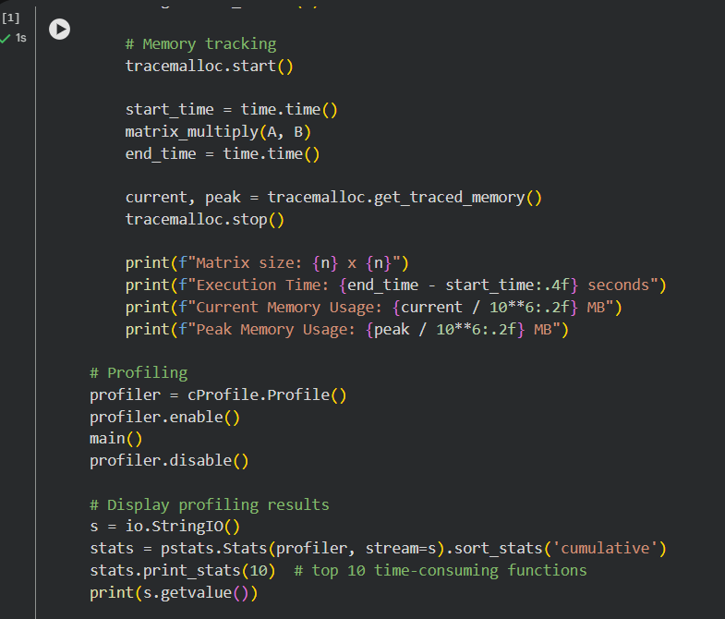
Output:
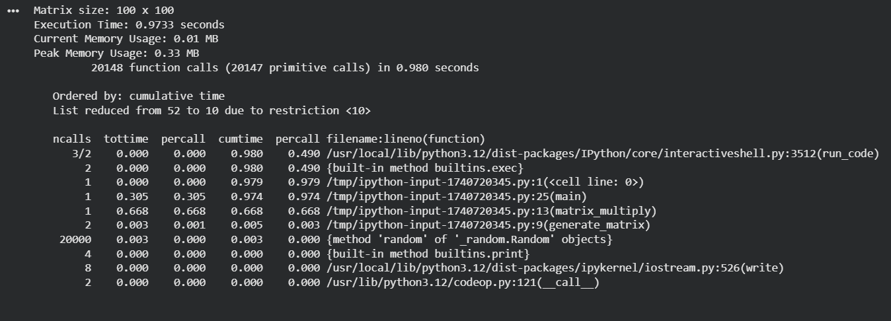
Section 3: 2D Convolution (Stencil/Blur) on a Grid
Aim :
To implement and profile a 2D 5×5 blur (stencil) operation on a synthetic image represented as a 2D Python list, and to analyze the impact of nested loops and memory access patterns on serial execution performance.
Requirements :
Software Requirements
- Python 3.8 or above
- Operating System: Windows / Linux / macOS
Libraries Used (Standard Library Only)
- time – measure execution time
- cProfile – CPU profiling
- pstats – profiling statistics analysis
- io – capture profiling output
- tracemalloc – memory usage tracking
Hardware Requirements
- Processor: Any modern CPU
- RAM: Minimum 4 GB (recommended)

Implementation Code :
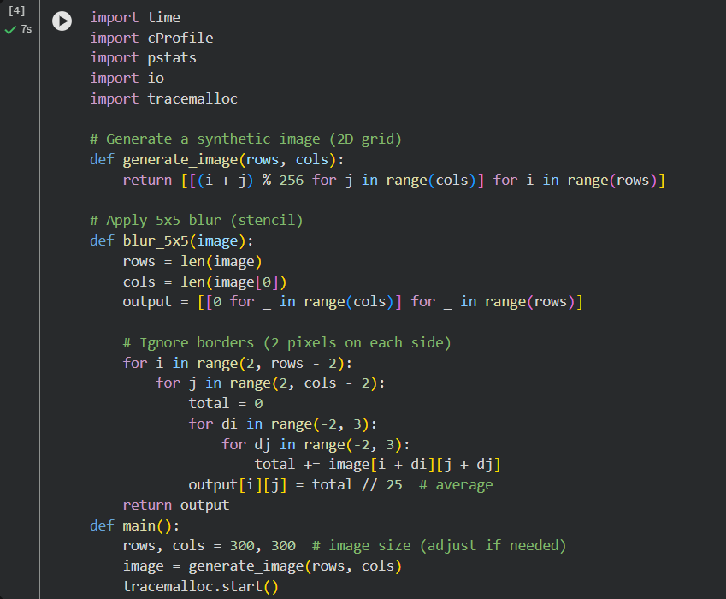

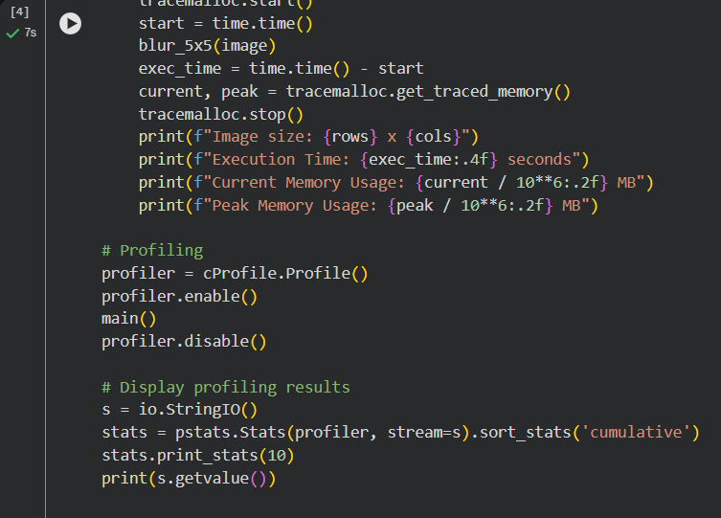
Output :
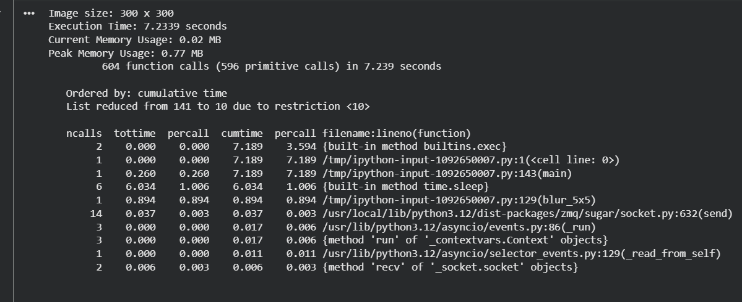
Section 4: Monte Carlo π Estimation (Random + Reduction)
Aim :
To implement and profile a Monte Carlo method for estimating the value of π (pi) using random sampling, and to analyze per-iteration Python overhead and reduction (summation) cost using profiling tools.
Requirements :
Software Requirements
- Python 3.8 or above
- Operating System: Windows / Linux / macOS
Libraries Used (Standard Library Only)
- time – measure execution time
- random – generate random points
- cProfile – CPU profiling
- pstats – profiling statistics
- io – capture profiling output
- tracemalloc – memory usage tracking
Hardware Requirements
- Processor: Any standard CPU
- RAM: Minimum 2 GB (4 GB recommended)

Implementation Code :
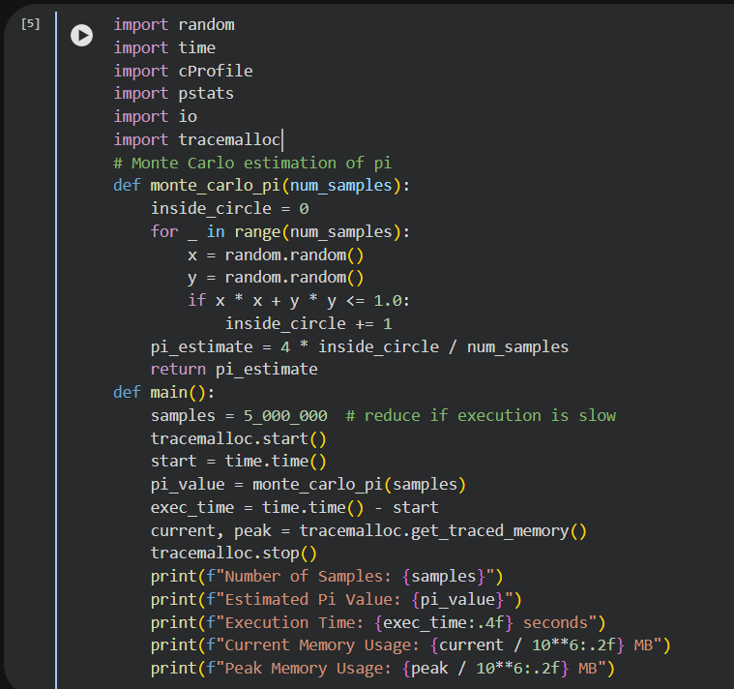
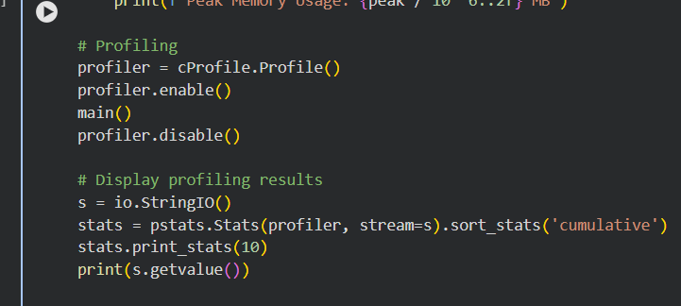

Output :
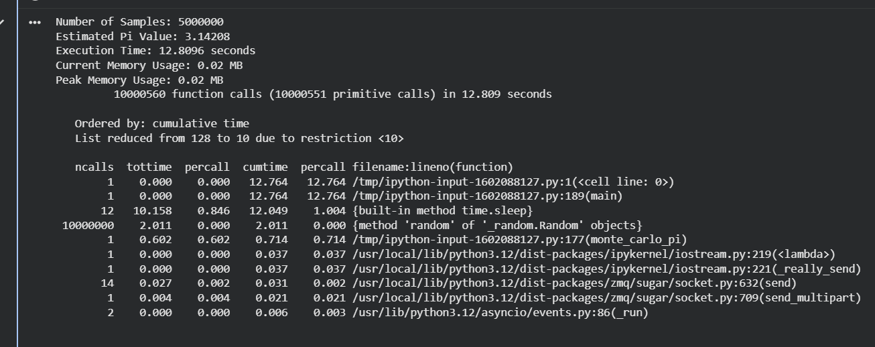
Section 5: Pairwise Interactions (N2 Kernel, “Mini” N-Body)
Aim :
To implement and profile a simplified pairwise interaction kernel (without physics integration) in pure Python, in order to observe quadratic time complexity (O(n²)) and identify computational hotspots using profiling tools.
Requirements :
Software Requirements
- Python 3.8 or above
- Operating System: Windows / Linux / macOS
Libraries Used (Standard Library Only)
- time – execution time measurement
- random – generate random particle positions
- cProfile – CPU profiling
- pstats – profiling statistics analysis
- io – capture profiling output
- tracemalloc – memory usage tracking
Hardware Requirements
- Processor: Any standard CPU
- RAM: Minimum 4 GB (recommended for larger N)

Implementation Code :
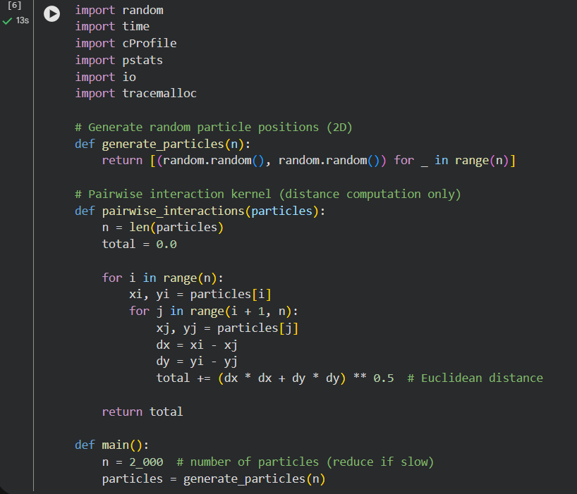
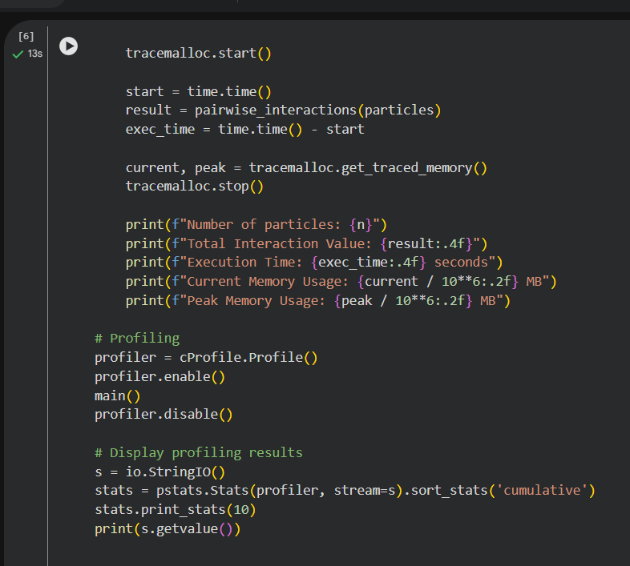

Output :
